# Aim

* To determine the accuracy of three relative humidity sensors
* To determine whether or not any of the relative humidity sensors requires a calibration function

# Method

* The three sensors, microcontroller, and battery were placed inside a small, sealed glass desiccator containing a saturated sodium chloride solution
  + At 25°C, a saturated NaCl solution keeps the humidity at a level of approximately 75.29%
  + At 20°C, a saturated NaCl solution keeps the humidity at a level of approximately 75.47%
* An on-board data logger recorded humidity samples at approximately 7-second intervals
  + Each sensor’s temperature reading and temperature-adjusted relative humidity reading was taken
* The desiccator was left in an air-conditioned room overnight for over 19 hours with the temperature set to 23°C
* For each sensor, the temperature and humidity readouts were compared to find causes of humidity change
  + The recorded readings were also compared to the datasheet accuracy to find if the data is in the acceptable range.

|  |  |  |  |
| --- | --- | --- | --- |
| Sensor | RHT03 | HTU21D | SHT15 |
| RH accuracy at 70% – typical (max) | $±2\%$ ( $±5\%)$ | $±2\%$ ( $±3\%)$ | $±2\%$ ( $±2\%)$ |
| Temperature accuracy at 25°C – typical (max) | $±0.5°C$ $\left(±0.5°C\right)$ | $±0.3°C$ $\left(±0.4°C\right)$ | $±0.3°C$ $\left(±0.3°C\right)$ |

* Finally, the temperatures, then the humidity of all three sensors were compared relative to one another.

# Results

* Test started at 14:22:55

## RHT03

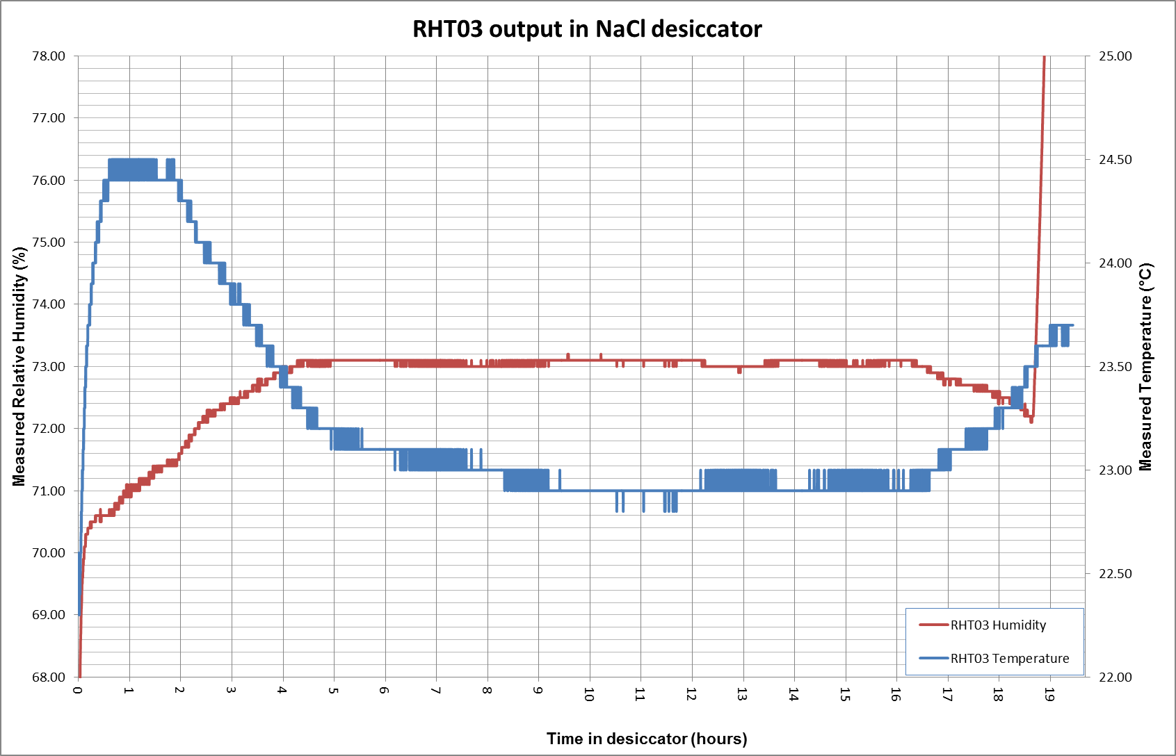

Figure - RHT03 sensor output

* Humidity reached a steady value of approximately 73.0% after 4 hours
  + This value represents an error of -2.3% from the set humidity
* The temperature stays constant for most of the test, but begins to rise at T+16 hours, which relates to 06:23 AM
* After approximately 18.5 hours into the test, the measured humidity rapidly climbed to a maximum of 99.90%RH, where it remained for the rest of the test.
  + No known external events occurred at this time

## HTU21D

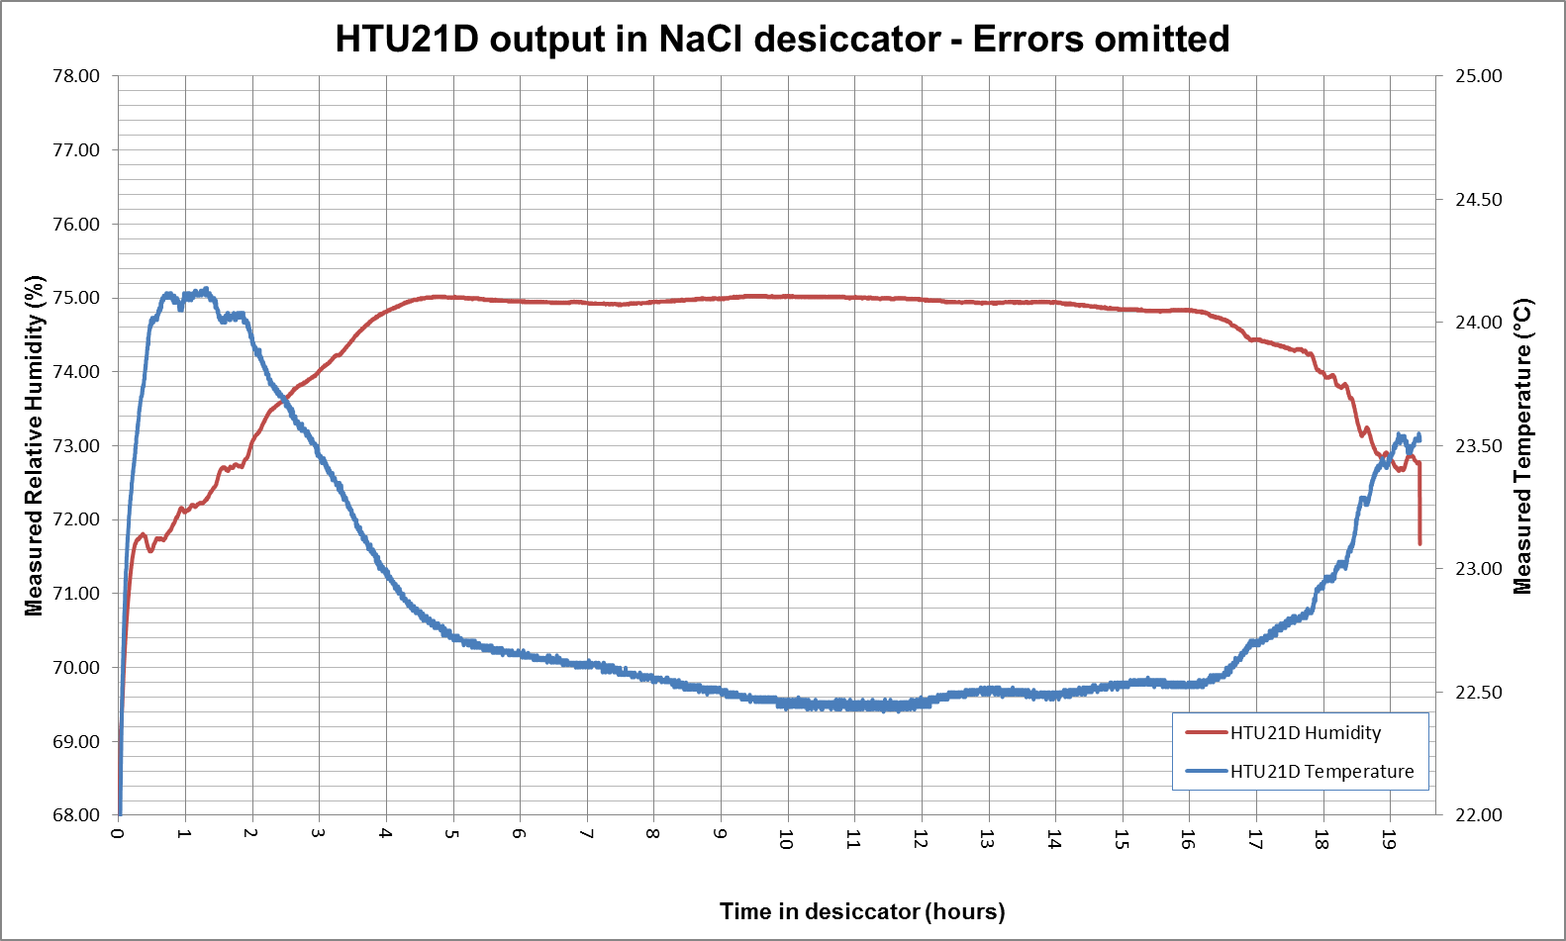

* Measured output reached steady-state after 4 hours with a value of approximately 75.0%
  + This value represents an error of less than 0.5%
* The recorded data contained error codes as a result of i2c bus timeout
  + These readings have been excluded from the graph

## SHT15

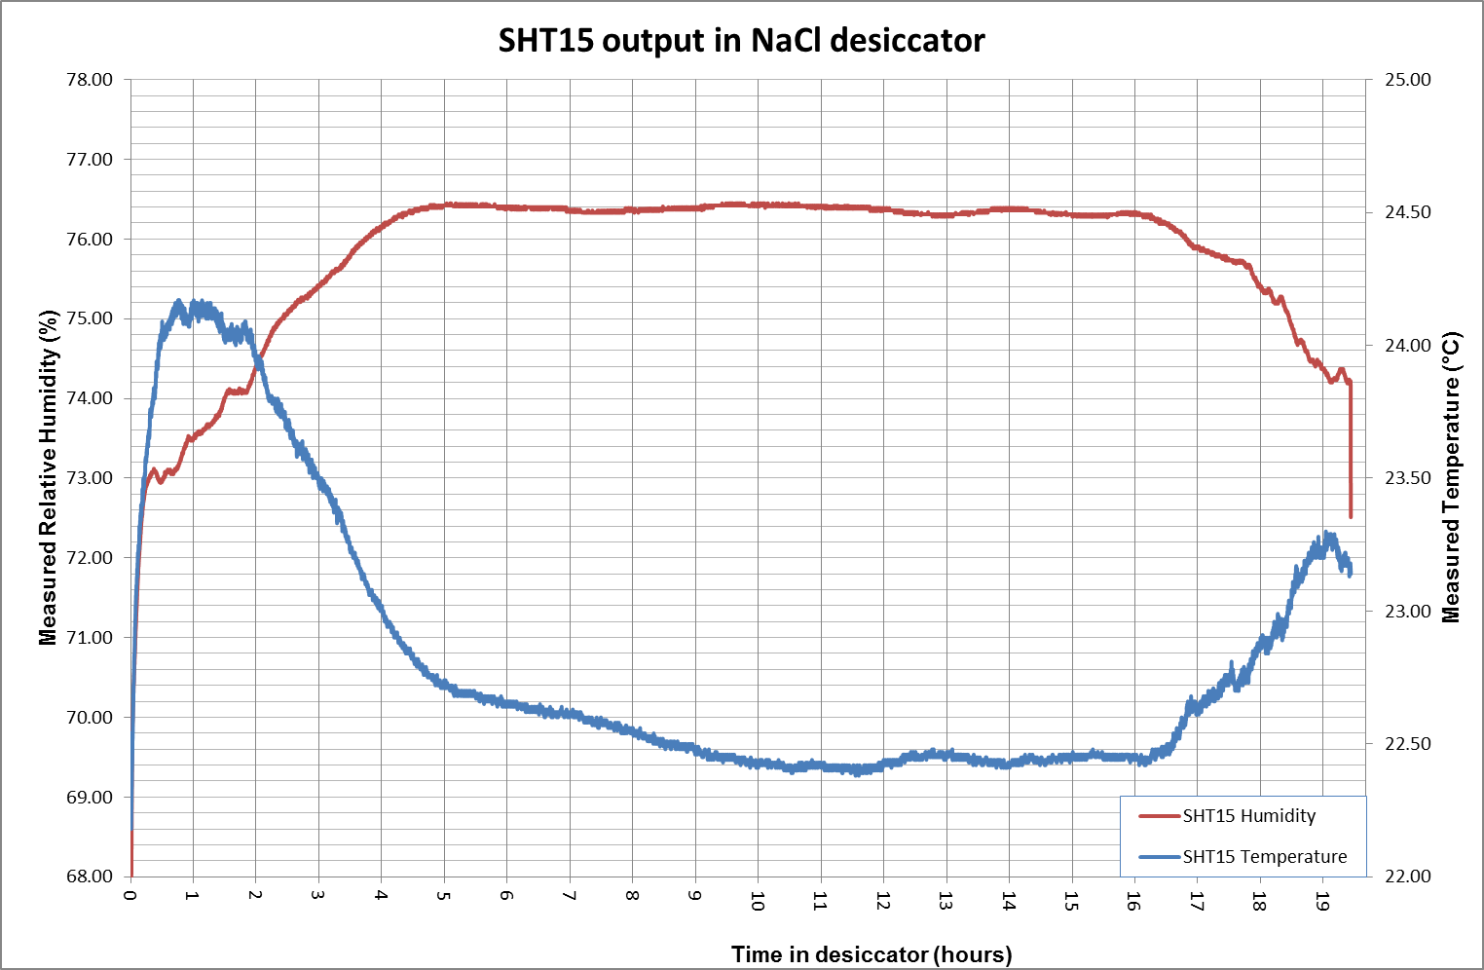

* Humidity reaches steady state after 4 hours, at a level of approximately 76.3%
  + This relates to an error of +1.0%

## Temperature – All Sensors

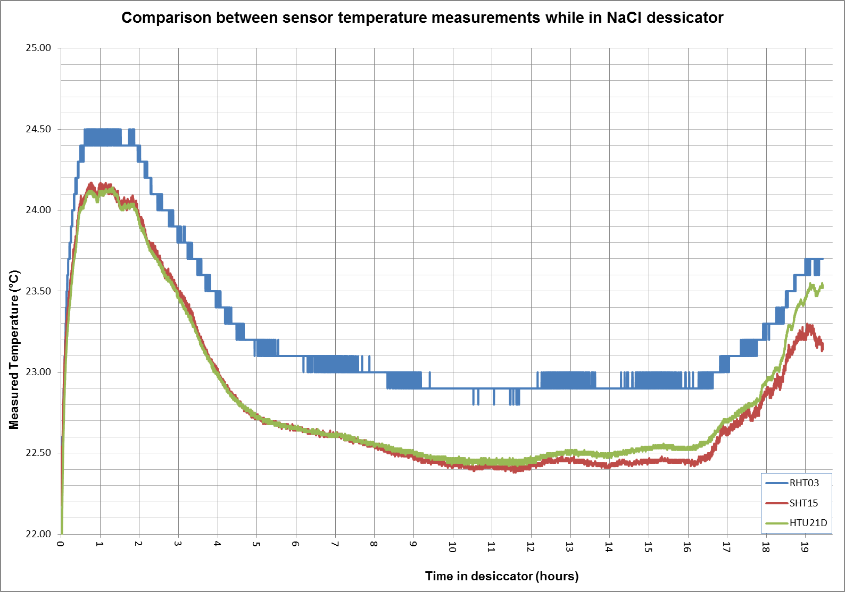

* The SHT15 and HTU21D sensors measured very similar temperature values for the entire duration of the test
* The RHT03 sensor had consistently higher temperature readings than the other two sensors (approx. +0.3°C)
* While the room temperature is set to 23°C through air conditioning systems, the temperature inside the desiccator changed

## Humidity – All SEnsors

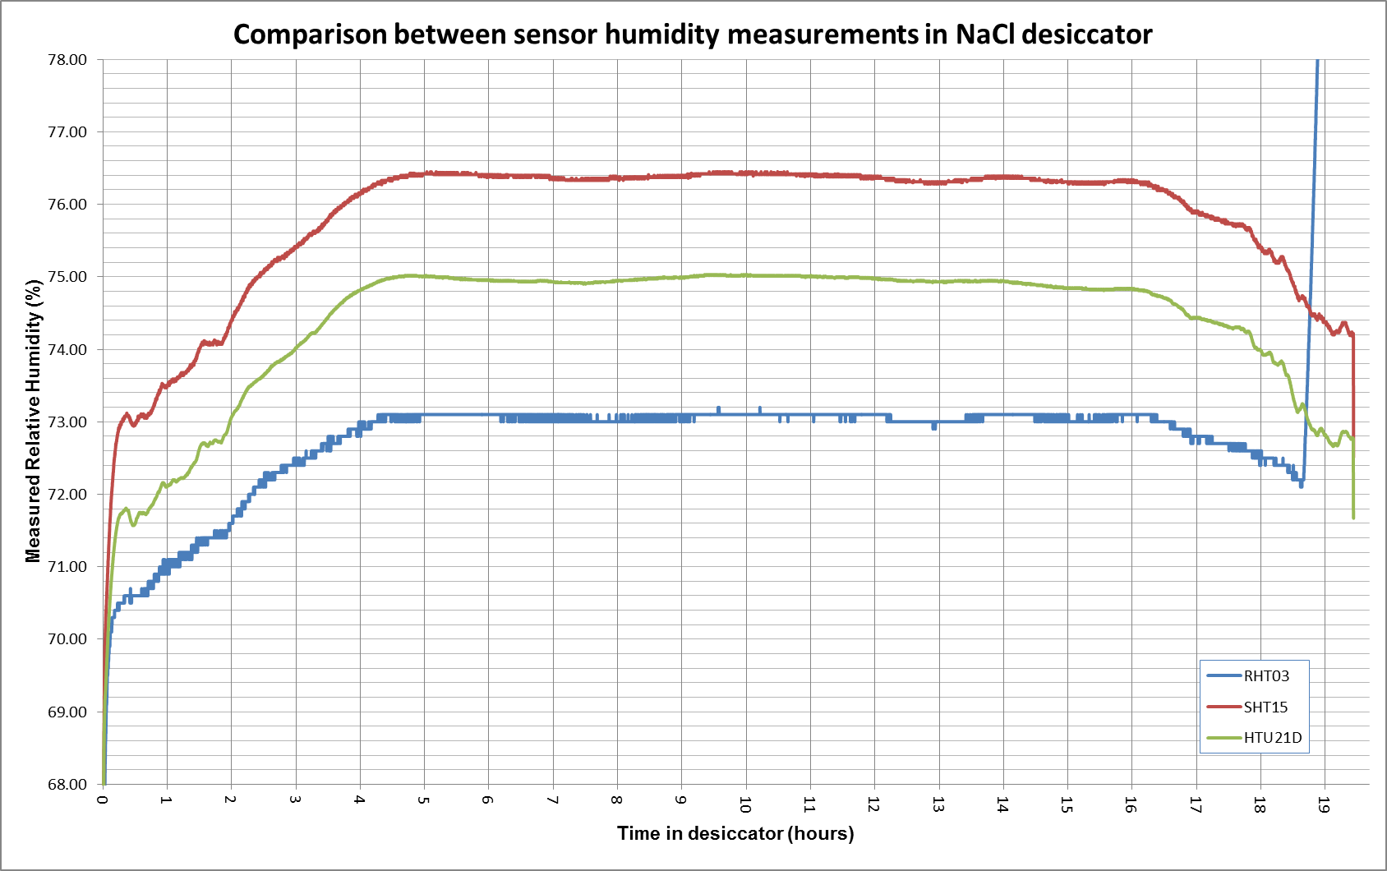

* All humidity curves are very similar in shape (with the exception of the RHT03 sensor failure)
* All three sensors have a similar settling time and behaviour

# Discussion

* All three sensors reached steady state after 4 hours, which corresponds to 18:22, and sunset
  + After this time, building occupancy would be low, if not entirely empty
  + Heat from the sun is still dispersing
  + Humidity is at its highest level, while temperature is dropping to its minimum levels
* As the sun starts to rise again, the measured temperature climbs while relative humidity drops
  + This is to be expected as the relative humidity has an inverse relationship to temperature
  + However, this would also suggest that while the room temperature is moderated by air conditioning, the desiccator is in a location that is still affected by heat from the sun
* The measured temperature stays reasonably consistent between T+9 and T+16 hours
  + Stable temperature measurements should also mean more stable humidity readings
  + For all sensors, the humidity during this period was within the manufacturers accuracy tolerances
  + In order of most accurate to least accurate for this test:
    - HTU21D: <0.5%
    - SHT15: <1%
    - RHT03: < 2.3%
  + The RHT03 sensor is the only sensor outside the manufacturer’s typical error margins
  + The RHT03 sensor is also the only sensor to fail during this test
  + Causes of failure are unknown and cannot be determined from the recorded information
  + These factors make the RHT03 the least reliable of the sensors
* Timeout errors caused many of the HTU21D readings to be unusable and excluded from the results

# Conclusion

* From this initial test, the sensors displayed humidity reading accuracy within the manufacturer’s specified error margins.
* As such, none of the sensors requires corrective calibration at this stage.
  + The RHT03 sensor may benefit from an offset